Detailed Design
For our project, we are designing a wirelessly controlled ground rover with a first person view camera. The user controlling the rover can set its speed via two rocker potentiometers and can set the angle of the camera based on the position and angle of the users head. If the user looks up, the camera will position itself to look in the same direction, providing the user a first-person perspective of robots position. The system is built up of two main systems, the robot and the users, and four lower-level subsystems, data transfer, data receive, analog video stream(both transmit and receive), and the control system to map the users head position to the camera angle. The four lower-level subsystems are split up among the group, and once each member completes their task, we can combine the four subsystems to create the two main systems.
The rover itself is a very simple design. Its a 4 wheel drive robot controlled with differential steering. This means that the left and right side of the robot will be controlled seperatly, and in order to turn, one of the sides will have to be moving at a higher speed than the other. This control scheme is most popularly used with tanks, which is why differential steering is often called tank steering. Also on the robot will be a camera, placed on a pan-and-tilt mount. This pan-and-tilt mount will be controlled by two servo motors. Servo motors are a specialized motor that can rotate to a specified angle based on an input ac voltage. The robot will be controlled by a PIC16f1829 micro-controller. The micro-controller will be connected to an RF transceiver, as well as an H-bridge that will be used as a motor controller. The camera on the robot will be connected to a 500 mW, 900 MHz radio transmitter, which will transmit an analog video stream to the user.
The control for the user is a little bit more complex of a design. The user controls are made up of two objects, the video goggles and the controller. The controller itself is quite simple, made up of two rocker potentiometers. The analog values of these potentiometer will set the speed of the robot; the left rocker pot will set the speed of the left side of the robot, and the right rocker pot will set the speed of the right side of robot. The video goggles will be receiving the analog video being sent from the robot. The RF video receiver is already built into the video goggles. Attached to the video goggles will be three gyroscopes, each corresponding to a different axis in space. Based on the values of the gyroscopes, the camera will try to move to be at the same angle as the users head position. These three sensors and the two rocker potentiometers will be connected to another PIC16f1829 micro-controller. Also connected to the micro-controller will be a SPI RF transceiver which will send data to the robot.
The micro-controller will only affect the robot state after it has received all the data need off of the RF tranceiver. There should be about 5 bytes of data sent over the channel within a specific frame. After these five bytes of data are read, the micro-controller will control the robot. All controls are done using PWM signals. Two PWMs signals are sent to the H-bridge to control speed of both sides of the robot. The speed of the robot will be based on the duty cycles of the PWM signals. The two other PWM signals are sent to control the pan-and-tilt servos. The angles of the servos are based on frequency of the PWM signals.
To make the system, we further broke the system down into four subsystems, data transfer, data receive, analog video stream(both transmit and receive), and the control system to map the users head position to the camera angle. Vijay Natarajan is responsible for data transfer. This subsystem is responsible for building and designing the controller for the user, and making sure that data can be transferred from the user within a proper frame, so that the data can be read properly. Matt Klose is resposible for data receive. This subsystem is responsible for properly receiving data from the RF channel, and be able to break the frame up into individual data structures. Shrimant Saxena is responsible for the analog video streaming, making sure that the video stream sent from the RF transmitter can be demodulated and displayed on the video goggles. Eric Anderson is responsible for the control system mapping the users head position to camera angle. This is the most in depth aspect of the project, so this subsystem may be worked on by multiple group members. This subsystem is responsible for analyzing gyroscope data, and using it to position the pan-and-tilt servos on the camera mount.
Vijay Natarajan:
I am in charge of designing the both the data subsystem of the controller for the system and designing the system that will take the control data and transmit the data over a wireless radio channel to the robot in order to control the motors and servos on the robot. The controller being used for the system is going to be built by us and has a very simple design. The controller is going to be made of two subsystems; the video subsystem and the data subsystem. The video subsystem of the controller is made up of a pair of analog video display glasses and 900 MHz RF receiver. This subsystem is being designed and built by Shrimant Saxena, and will provide the user with a visual of what the robot is seeing. The data subsystem, which I am creating, will be sending data from the user to the robot to set the angle at which the camera is facing, as well as setting the speed and direction of the robot.
The data subsystem is built up of 5 parts; a PIC micro-controller, a digital gyroscope, a SPI RF transceiver IC, and two Rocker Potentiometers. The two rocker potentiometers are going to be used to set the speed of the left and right sides of the Robot. The two sensors will be connected to PIC on two analog input pins. The digital gyroscope is connected to the PIC as well, either over an I2C bus or a SPI bus based on which digital gyroscope is bought. This three-axis gyroscope, which will be mounted to the video display glasses, will provide the PIC with the angle of the users head. All this data will be then be sent to the robot wirelessly using the SPI RF transceiver. On the robot side, there will be another SPI RF tranceiver to receive data. This system will be designed by Matt Klose. Then once the data has been extracted from the RF channel, the PIC connected to the RF tranceiver will then set the speed of the robot, and the angle that the camera should face. This control design will be done by Eric Anderson.
To build the data subsystem, all the parts will be added over time. First the controller will be designed to just use the rocker potentiometers, the SPI RF transceiver, and the PIC micro-controller. This setup will read a byte of digital data from both potentiometers, group these two bytes together into a frame, and sent over the SPI RF transceiver. The transceiver has a CRC preprogrammed into the IC, so all error checking will be done with the transceiver. If the data is properly sent over the channel, the robot should be able to set the speed of its motors. When Eric is finished with the control system mapping the users head to the servos for the camera, I will then attach the gyroscope to the video display glasses, and connect it to the PIC. The data from gyroscope should only be about two or three bytes. This data will be grouped together with the rest of the frame data being sent over the RF channel. Then we will check if everything is working in time.
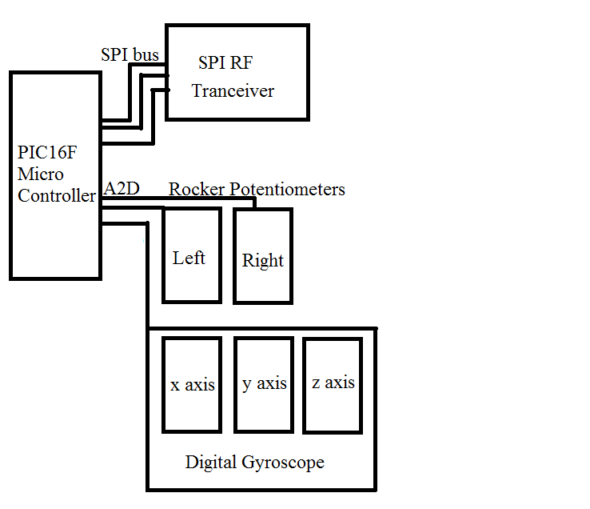
Matt Klose:
Receiving data from RF transceiver
We were planning on using wireless communication between an Android device and the Pandaboard, but we discarded that idea when we found the limitations of using digital video with our project. With digital communication we found that in order to meet our desired specs with regards to the video portion of the project, we needed to have a 1 Mbit/s transmission capability, which was unreasonable for our means.
What we chose to do instead was to utilize an RF transmitter/receiver combination with PICs at both ends to handle communications between the vehicle and the control system. The PICs would be able to interface with the transmitter and receiver, on one side receiving byte sized packets of data from the receiver and converting it into a control signal for the servos or the drive mechanism, and on the other side receiving data from the gyroscope head-tracker and the controller and converting it into packets to send to the transmitter. We still need to work out a few details, such as which transmitter/receiver we are going to use, and how exactly they are used, but that is the outline of the plan for the wireless communications.

Pan and tilt servo mount
The camera mount is an idea that hasn’t changed much since its inception. The plan is to have two rotational servos mounted such that their respective ranges of motion are perpendicular to each other. There would be one that would handle the left/right panning motion of the camera, and the other would handle the up/down tilt of the camera. The servos would be controlled by PWM signals from a PIC chip, and those signals would be determined by the data the PIC received from the RF communications relay described above.
These servos would have to be powerful enough to turn themselves and the camera at a rate comparable to natural head movement. Therefore, the rotational rate of the servos will have to be roughly 180 degrees/second, with load. This is a property we can check while we acquire the devices, so this is less a design hurdle and more of a shopping hurdle.

